Registering your personal device with Ivanti – MobileIron Go

- Open your Web Browser and go to https://mobileiron.com/go
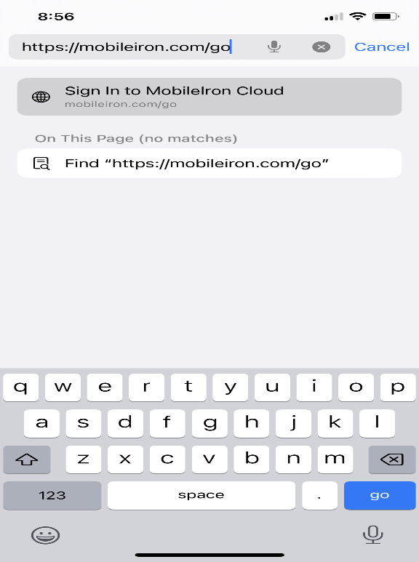

- Enter your State Email Address, then click Continue.
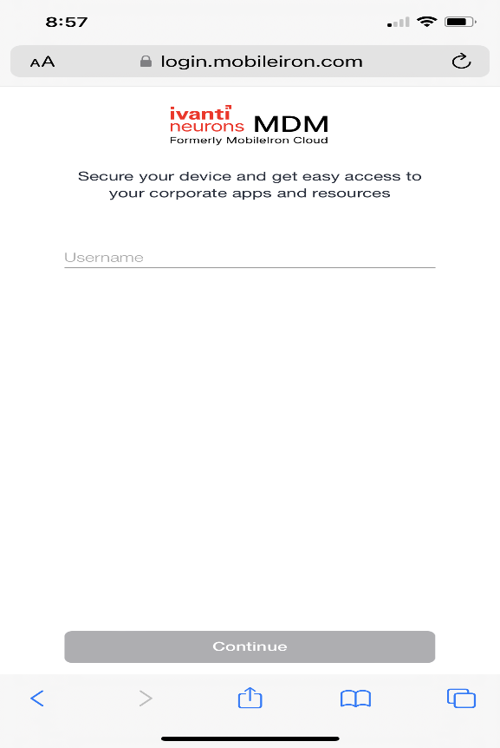
- Enter your Network Password and choose I own this device, then click Continue.
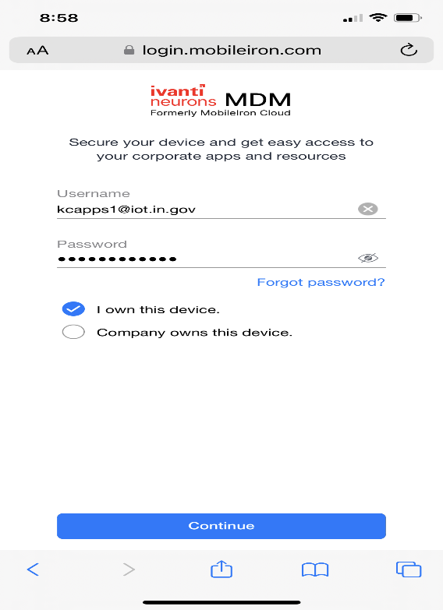

- Click on I Understand.
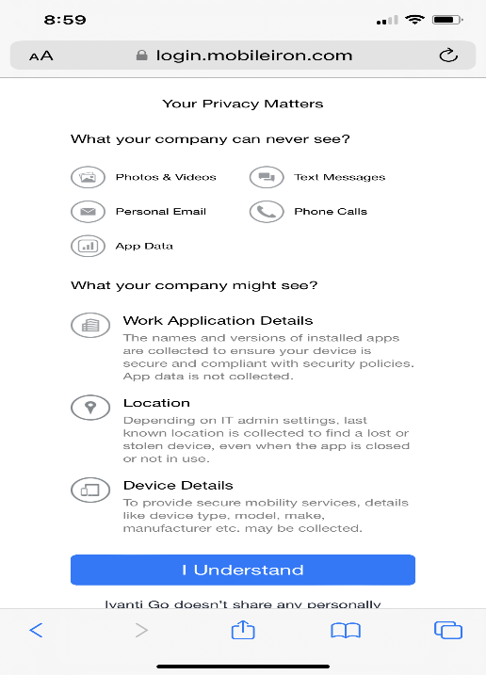

- Click on Allow.

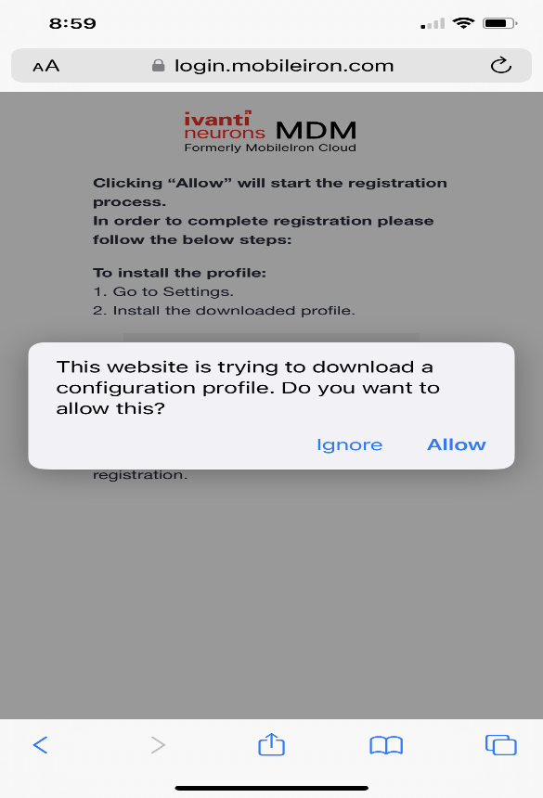

- Click on Close.
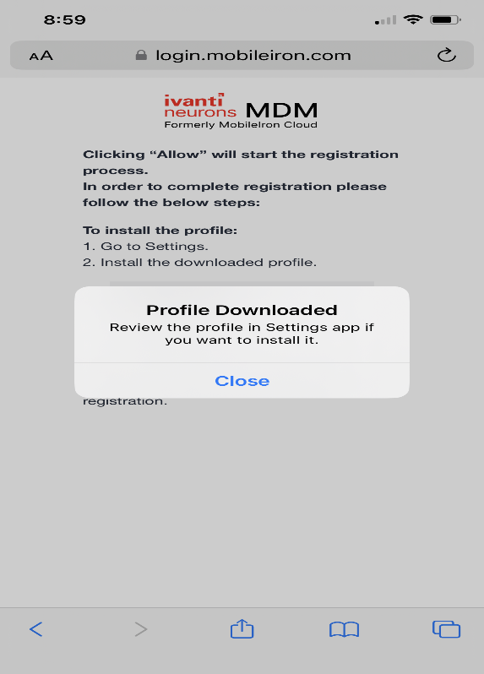
- Go to the iPhone Main screen and click on the Settings Icon.

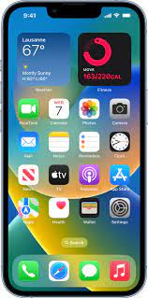

- Click on the General Tab.

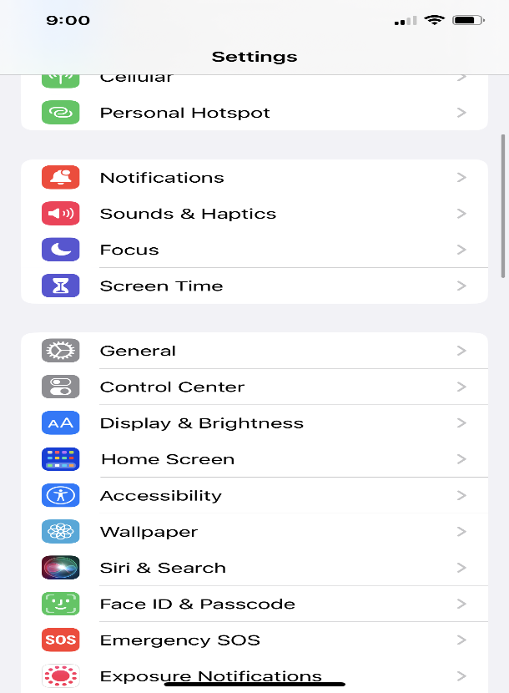
- Click on VPN & Device Management.

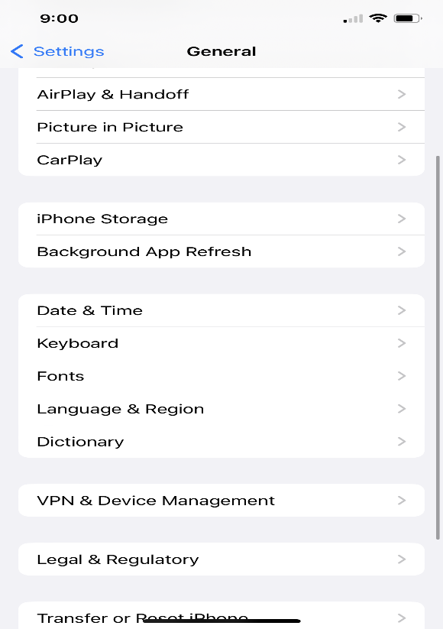

- Click on the Downloaded Profile.

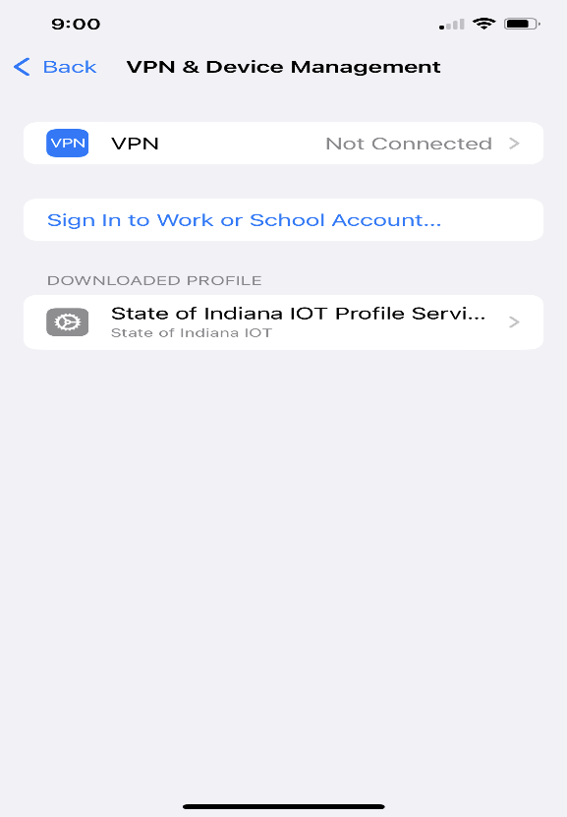

- Click on Install on the top Right.

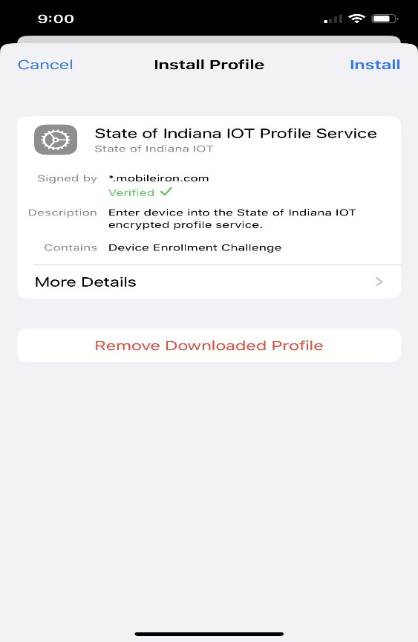

- Enter your iPhone Passcode.

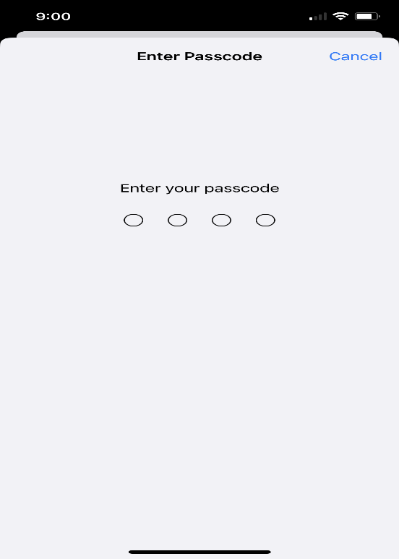
- Click Install.

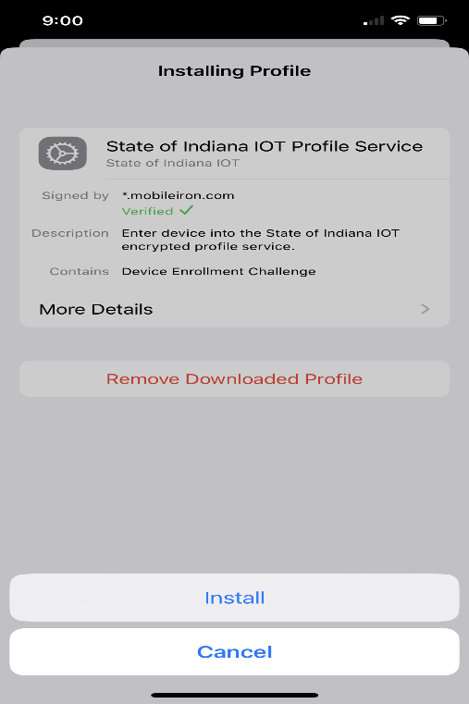

- On the Warning screen Click Install.

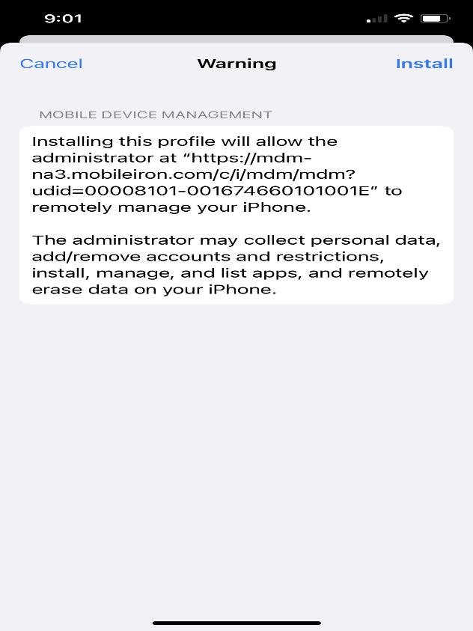

- Click on Trust.

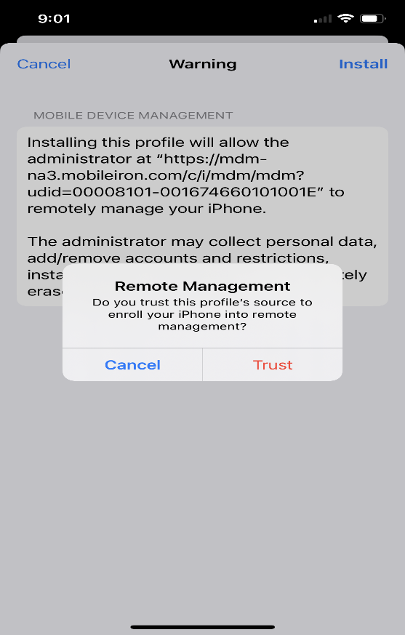

- Click Done.

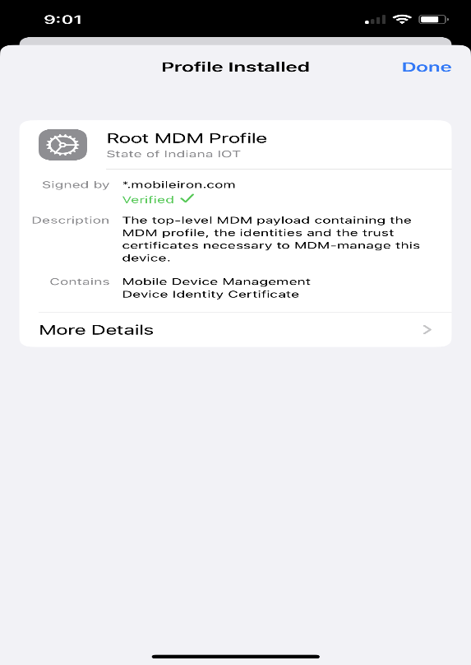
- Go to the iPhone Main Screen – pop ups will appear: Click on Cancel for Exchange Password and Dismiss for Edit Home Screen pop up.
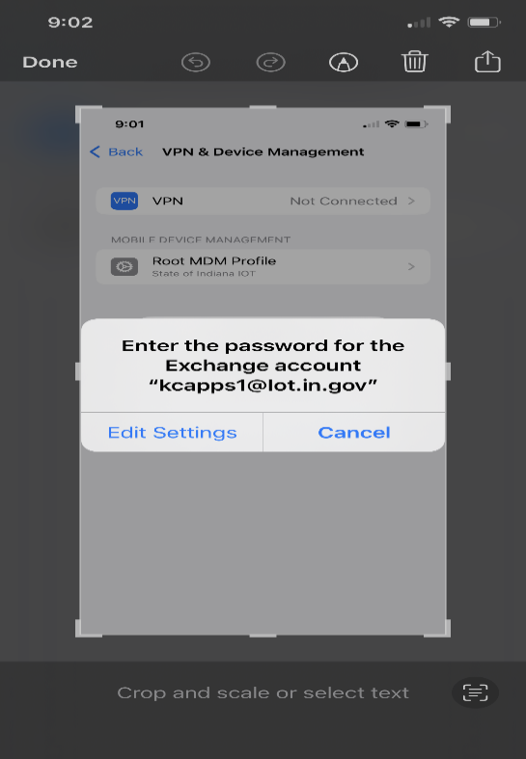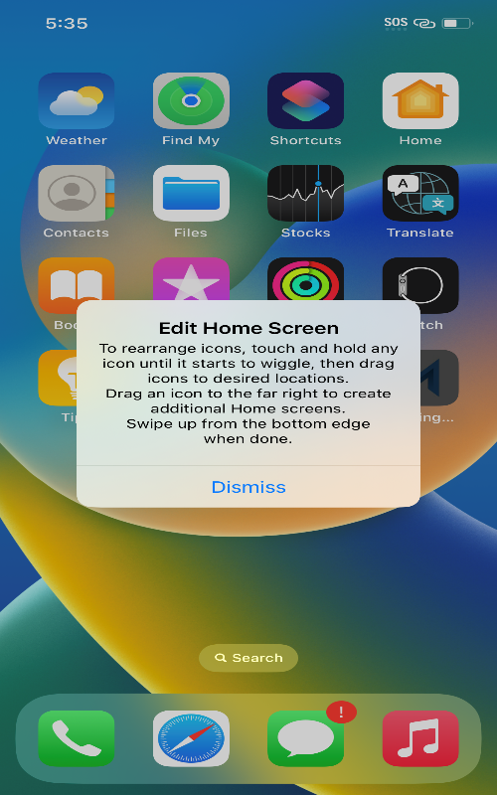

- Be Patient. App Installation icons will appear: Mobile Iron GO, Microsoft Authenticator, Password Reset, Microsoft Teams and App Catalog. When the apps finish downloading, click on the Mobile Iron Go app.
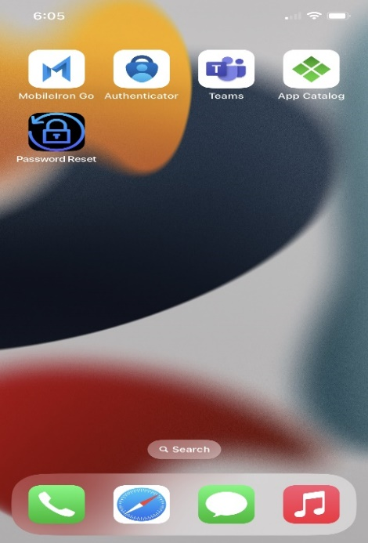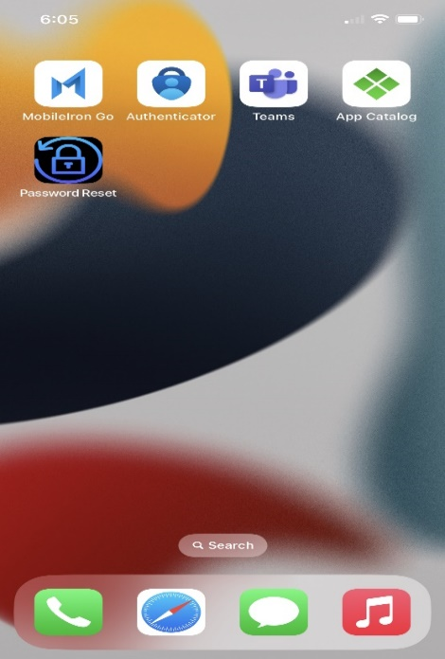

- Click on Allow for Notifications.

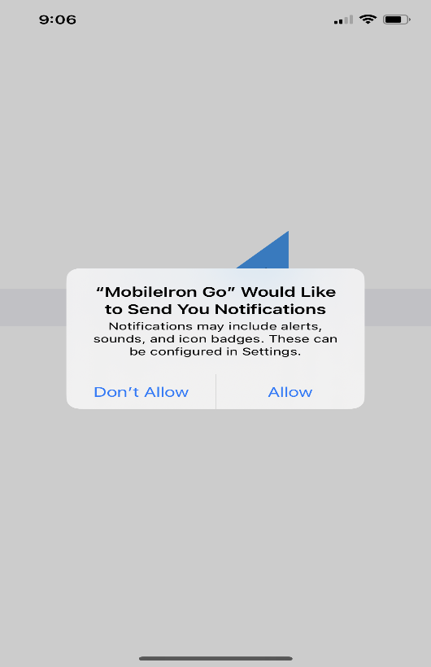

- Access your Microsoft Apps – Click Continue.
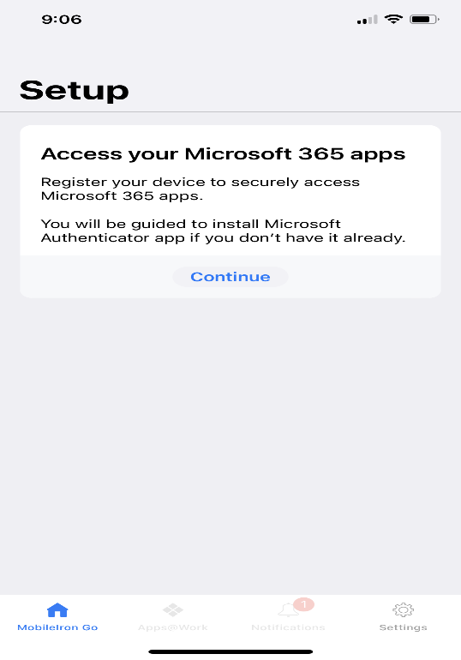
- You will be prompted to open the Microsoft Authenticator app.

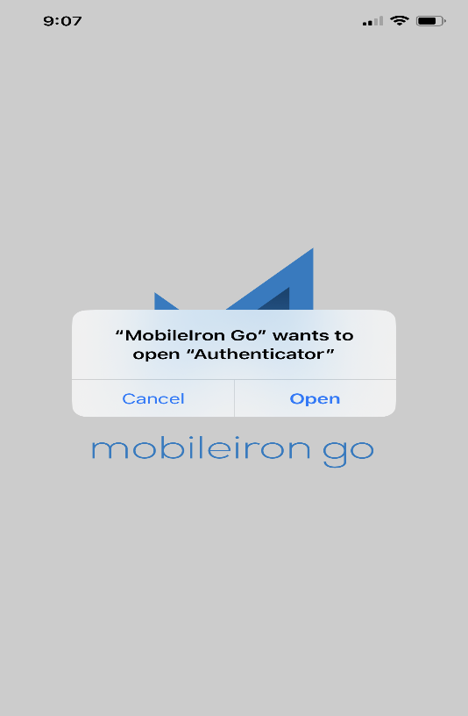

- Sign in with your State Credentials – Email Address – Network Password

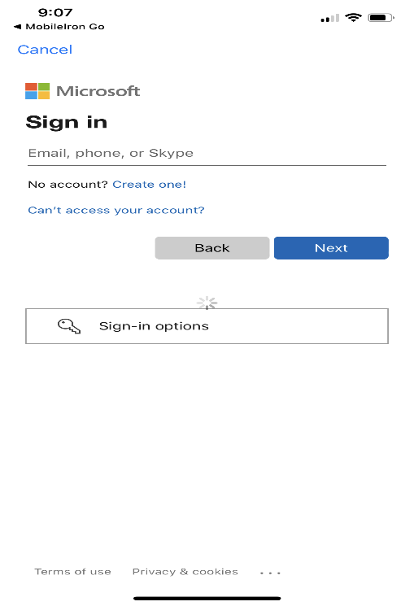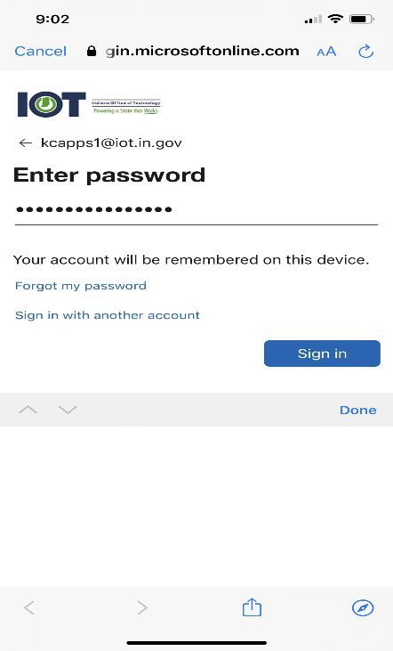

- Once the device has authenticated - Click on Register.
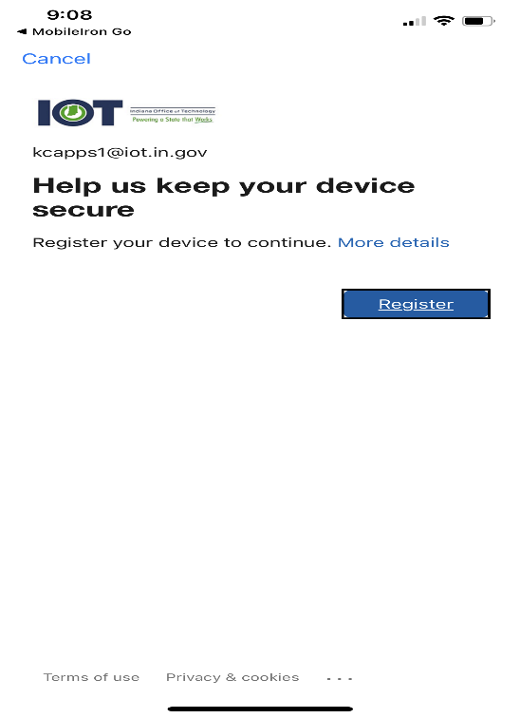

- Device Status – Your device will show successfully registered and will show Device in Compliance.
You can now access Apps@work from the Mobile Iron Go icon.

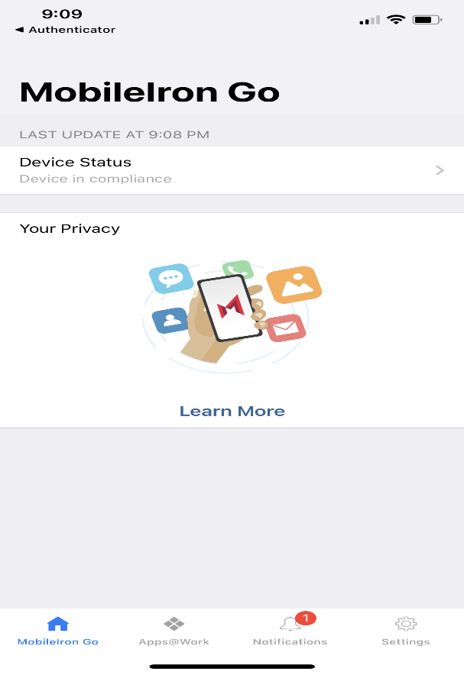

- Once Registration is complete, go to Settings then Click on Mail then Accounts.

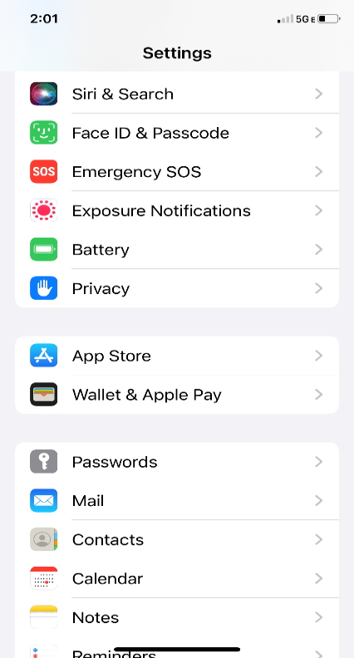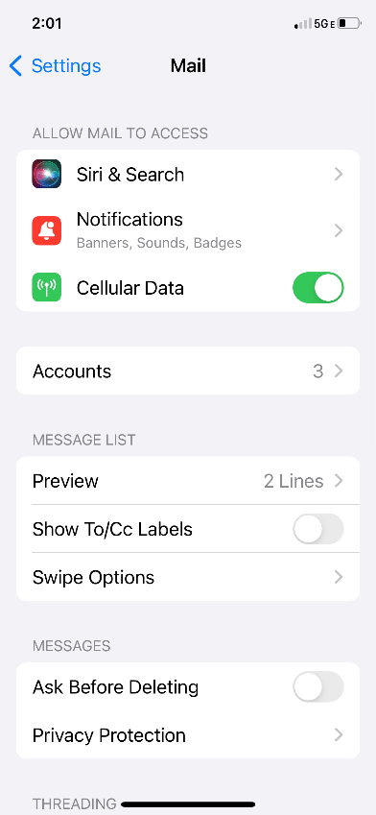

- Click on the Exchange Account then Click on Re-Enter Password.

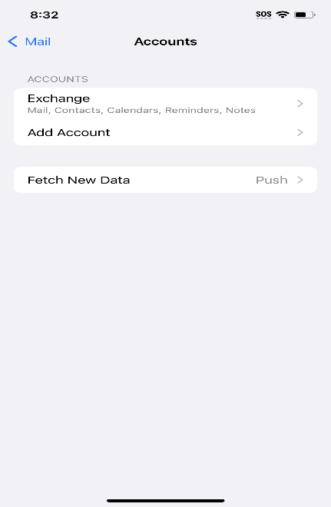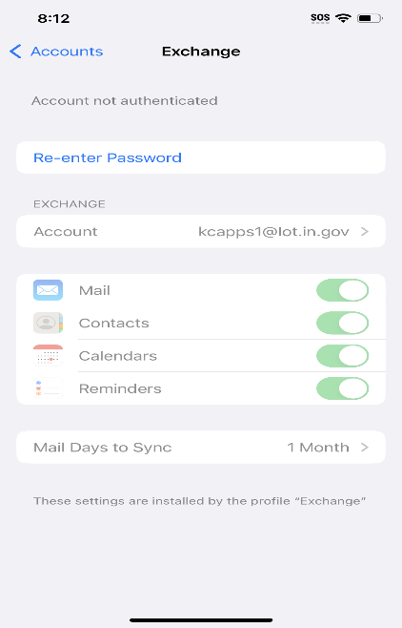

- Enter Network Password to Authenticate. After Mail authenticates, make sure the sync buttons are turned on.

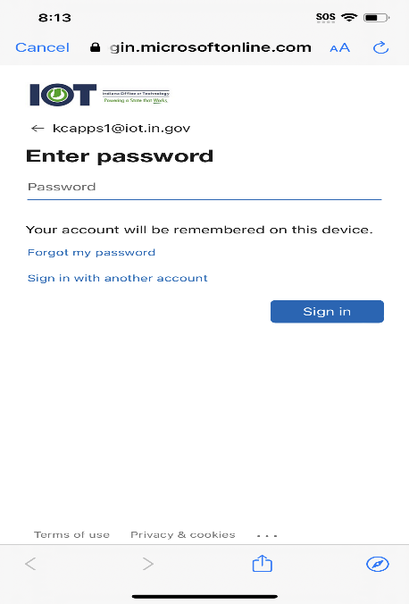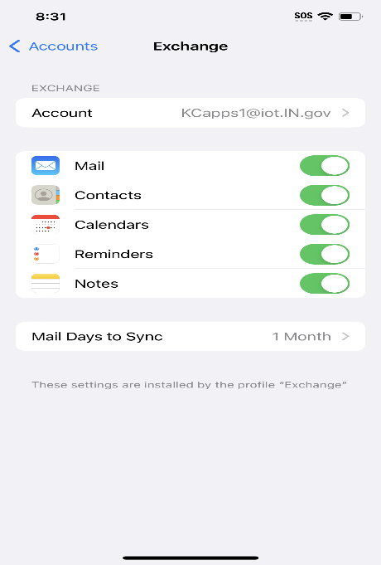

- Go to the iPhone Main Screen and click on the Mail icon then click on Continue.

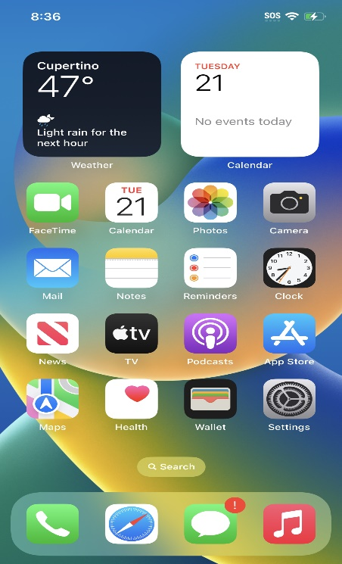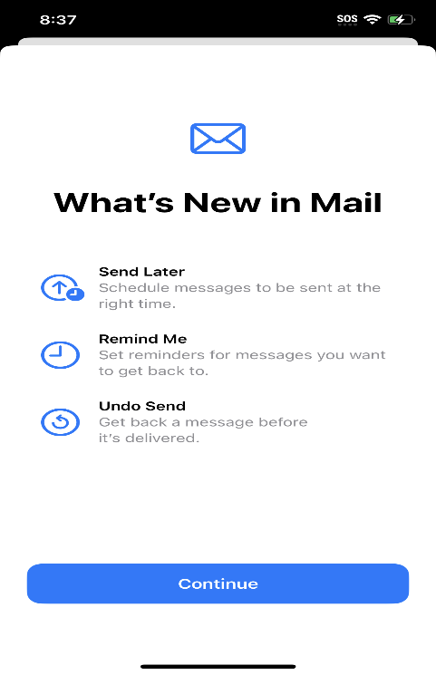

- Mail Privacy Protection – Choose Protect Mail Activity then click Continue.
- Choose Allow for Mail Notifications.

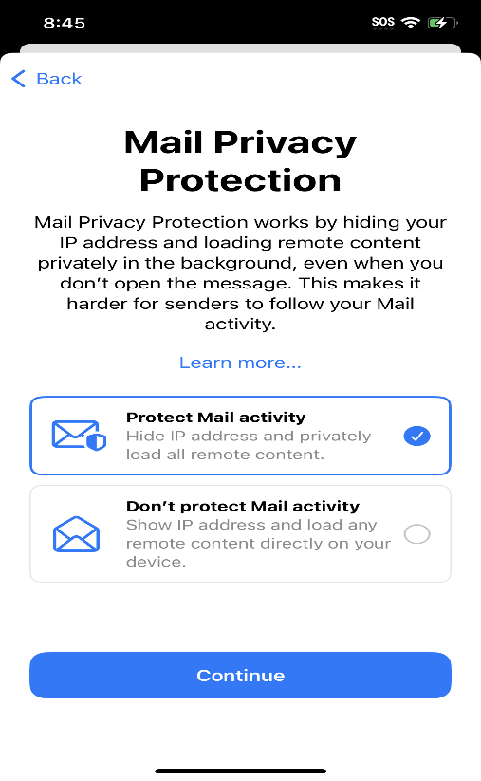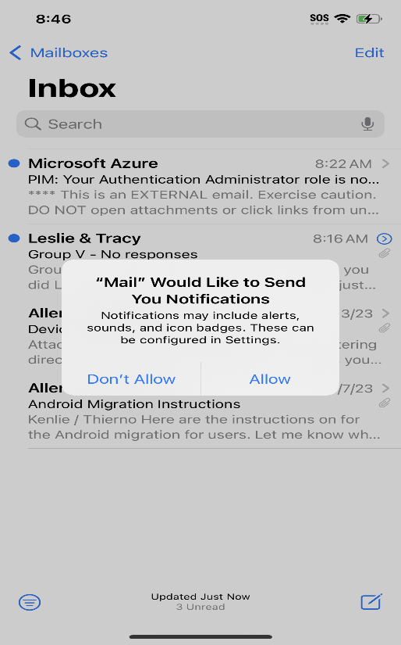

Your Exchange Mail account will update. Registration is complete.

