Medical Certifier Trouble Shooting Guide

The purpose of this guide is to aid in resolving issues that may prevent the medical certifier from being able to complete and affirm the certification of the medical portion of a record.

The procedures spelled out here are also touched-on in part in the video training guides and the text document guides found on the resources page: https://www.in.gov/isdh/28076.htm

Under the heading DRIVE Training and Online Demonstrations, the recorded videos of user training are available.
In the DRIVE Medical Certifier Recorded Training the Cause of Death section roughly occurs between minutes 22:41 and 29:35.

In the DRIVE Coroner Recorded Training the Cause of Death section roughly occurs at minute 17:43 but is more fully covered in the DRIVE Medical Certifier Recorded Training.

Under the heading DRIVE User Guides are the text documents pertaining to each process.

In the DRIVE User Guide Medical Certifiers, the Cause of Death process begins on page 26.

Table of Contents

I can’t access the record through my queue………………………………………………………………………. Page 3

I am unable to enter the Date Signed on the Certifier tab and it’s stopping me from certifying the record ……………………………………………………………………………………………………..……….…………….…... Page 3

All the menu tabs are green, but the system won’t let me certify the record. It says FIPS Coding Required …………………………………………………………………………………………………….……………………… Page 4

All the menu tabs are green, but the system won’t let me certify the record. ………………….. Page 4

All the menu tabs are green, and I’ve added a late filing reason, but the system won’t let me certify the record. ………………………………….………………………………………………………………………….. Page 8

Cause of Death issues

Best estimate of the interval ……………………………………….………………………….…………..… page 8
Abbreviations …….……………………………….………………………..……………………..….…………..… page 8
Listing conditions …………………….…………………………………….…………………….……………..… page 8
Etiology keywords …………………………………………………………..………………..….……………..… page 9
Ill-defined terms ……………………………………………………………..…………………………………..… Page 9
Cause of Death field icons …………….………………………………….………….……………………..… page 10
Validation Results ……………………………….………………………………..……..……………….……..… Page 11
Overrides …………………………………………..………………………………………………………………..… Page 12
Recording neoplasms …………………………………………………………….……………….………………Page 13
Ill-defined term without Validation Results ………..…………………………..…………………..… Page 14
Examples of neoplasm grading schemes …………..…………………..……………………………… Page 14
Fatal injuries issues .……………………………………………..…………………….…………………..……… Page 15

Coroners must complete the Coroner Review to complete certification ……………………….... Page 16

There are several factors that can prevent a medical certifier from completing certification of a record. If all the tabs under the Medical Certification heading of the menu are green but the Certify tab does not appear under the Certifier tab when the Validate Page button is used, then it is most likely due to one of the following reasons.

I can’t access the record through my queue.

The first time a medical certifier attempts to retrieve a record, to gain ownership and have write-access to the record, it must be accessed through the Menu tabs Life Events >>> Death >>> Start / Edit New Case. From there you will need to perform a search for the record to ensure against duplication.

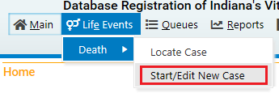

Performing a search will allow you retrieve the record and the first time in, the pop-up below will occur. Clicking “OK” will grant ownership of the record.

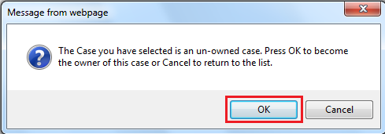

On the resources page (https://www.in.gov/isdh/28076.htm) under the heading DRIVE Quick Guides is the document: DRIVE Start/Edit New Case vs. Locate Case Guide. This covers the process in its entirety.

I am unable to enter the Date Signed on the certifier tab and it’s stopping me from certifying the record.

The date signed field will auto-populate upon certification of the record. It is not a manually filled field. If the Date Signed field won’t fill, it’s because of one of the reasons covered below.

All the menu tabs are green, but the system won’t let me certify the record. It says FIPS Coding Required.

FIPS Coding is for the statisticians reviewing data and irrelevant to the process for Medical Certifiers and Funeral Directors.

All the menu tabs are green, but the system won’t let me certify the record.

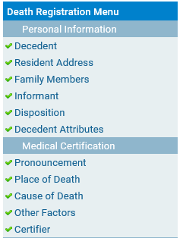

If you are trying to complete the certification later than 5 days after the indicated Date of Death (regardless of the reason why) a Late Filing Reason must be added through the Comments tab under the Other Links heading.

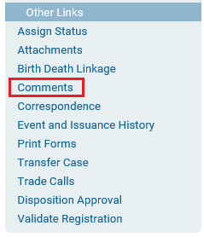

When you click on Comments a pop-up window will appear. Click on the button New Comment.

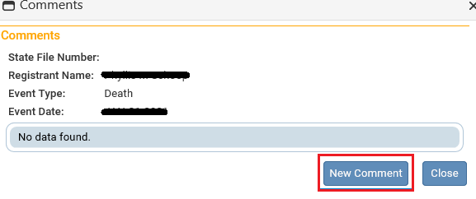

A sub-window will open with a drop menu labeled Comment Type. Select Late filing reason.

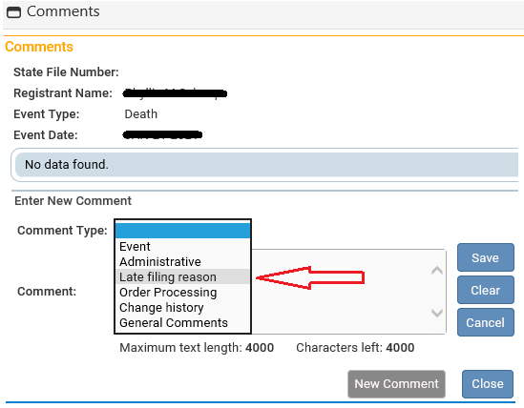

Below the drop menu comments can be typed into the Comment field. Upon completion click Save and then Close.

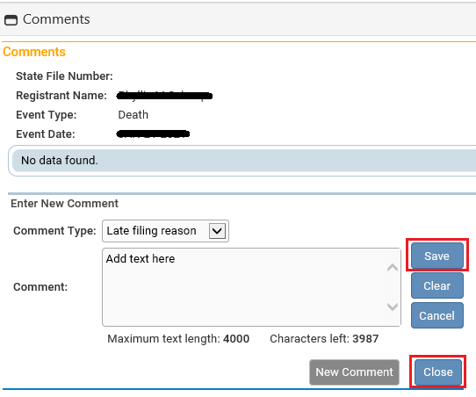

All the menu tabs are green, and I’ve added a late filing reason, but the system won’t let me certify the record.

This indicates that the Cause of Death is incomplete, even if the tab has a green check on it.

At the top of the Cause of Death page is an active link labeled NCHS Recommendations for Entry of Cause of Death. This provides general instructions for filing out the fields on Cause of death tab.

The Recommendations indicate that Medical Certifiers should use their best medical opinion.

Provide the best estimate of the interval between the presumed onset of each condition and death. If you don’t know you can use unknown or pending. Pending presumes that you will be adding an amendment later with the updated information.

Abbreviations and parentheses will prevent the record from being certified (e.g. “gi bleed” must be spelled out gastrointestinal bleed; COPD must be spelled out Chronic Obstructive Pulmonary Disease).

List only one condition per line in Part I. Additional lines may be added as needed. Each condition in Part I should cause the condition above it.

If two or more possible sequences resulted in death, or if two conditions seem to have added together, report in Part I the one that, in your opinion, most directly caused death. Report in Part II the other conditions or diseases.

When processes such as the following are reported, additional information about the etiology must be reported:

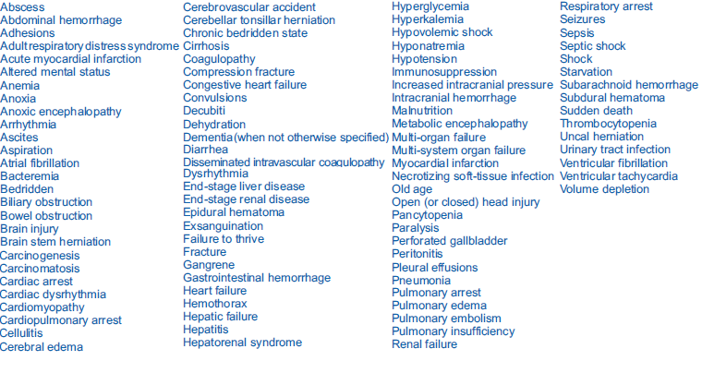
If an organ system failure is listed as a cause of death, you must report its etiology on the line(s) beneath it. Examples are as follows:
- congestive heart failure congestive heart failure due to cardiomyopathy
- hepatic failure hepatic failure due to cirrhosis
- renal failure renal failure due to Type I diabetes mellitus
- respiratory failure respiratory failure due to sepsis

In this vein, the terminal event (e.g., cardiac arrest or respiratory arrest) cannot not be used by itself. You must report the causes of the terminal event (e.g., cardiac arrest due to coronary artery atherosclerosis or cardiac arrest due to blunt impact to chest).

Keep in mind that if the subsequent term used (after due to) is a keyword reported above, more explanation will be required. Moreover, certain terms will generate error sub-notices through the Validate Page option and the Cause of Death fields will have their own icons.

In the following example, after validating the page the term cardiac arrest has been highlighted red. Clicking on the highlighted text will cause a blue explanation box to appear, indicating that the entry is ill defined. Also, the highlighted text cannot be overwritten.

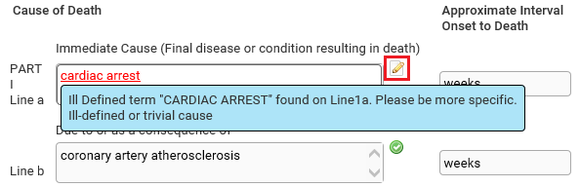

Clicking on the pencil icon to the right of the field will allow the text to be overwritten. The pencil icon will change to an alert icon as shown below.

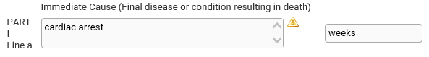

An alternate term can then be entered but must meet the same data standards.

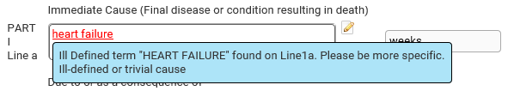

When an acceptable substitute is arrived at the green check will appear to the right of the field.

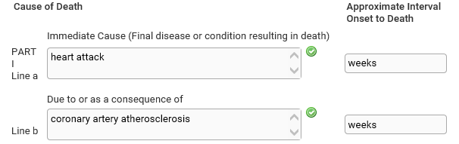

The following example has generated validation results at the bottom of the page indicating more explanation is needed. Note the yellow backgrounds of the fields.

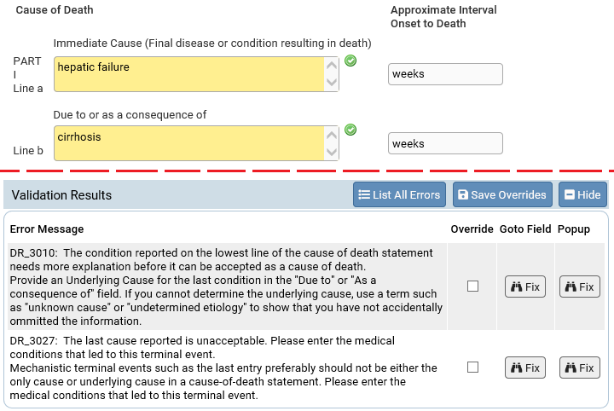

Yellow backgrounds are indicative of soft edits (which appear as yellow dots in the left-hand menu). A soft edit will not prevent you from certifying a record as a hard edit (red X) would do. However, you must check the Override box in the Validation Results and click the Save Overrides button to proceed. Note: The status bar below the subject’s name at the top of the record will now read Medical Valid With Exceptions and the yellow dot will remain. This is not considered best practice and you may be called upon to amend the record at a later date.

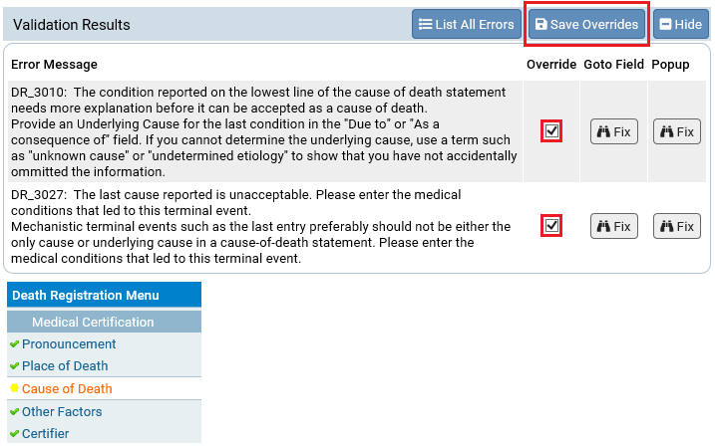

Sometimes expanding on the ill-defined term will resolve the validation issue as in the example below.

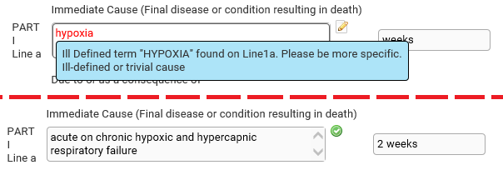

When indicating neoplasms as a cause of death, you must include the following:
1) primary site or that the primary site is unknown,
2) benign or malignant,
3) cell type or that the cell type is unknown,
4) grade of neoplasm, and
5) part or lobe of organ

The example below has generated both highlighted text and an Error Message in the Validation Results. Though the Override button appears, this entry could not be overridden as a soft edit. The Validation Results explain what is lacking.

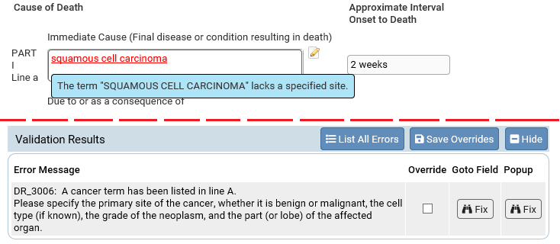

Only by spelling out the primary site, whether it is benign or malignant, the cell type (unknown if it is not available), the grade, and the part (or lobe) affected can the entry be resolved.

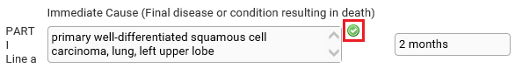

The below entry does not generate an Error Message in the Validation Results. It does generate red highlighted text which produces a blue explanation box (and will prevent certification).

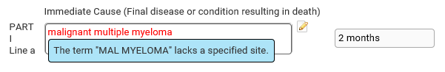

The issue is resolved by updating the entry to read: Malignant multiple myeloma of the vertebral column, pelvis, femur, skull. Moderately differentiated.

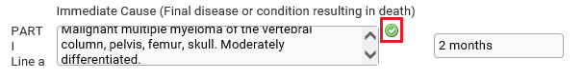
Note: You may get a green check without noting the grade of the neoplasm, but this is not considered best practice. While you may be able to certify the record, it runs the risk of being rejected by the Local Health Department (LHD). If this occurs, the status bar below the subject’s name will read: Medical rejected by LHD. An amendment will then be necessary.

While it is not necessary to note the stage of the neoplasm, the grade is expected. Below are some examples of grading schemes that would be accepted.

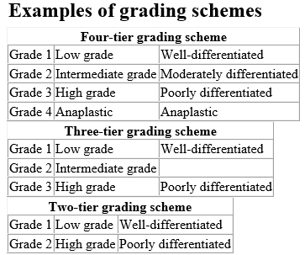

When it comes to injuries, you will need to report the fatal injury (e.g., stab wound of chest), the trauma (e.g., transection of subclavian vein), and impairment of function (e.g., air embolism).

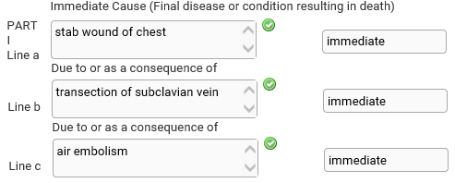
The following conditions and types of death might seem to be specific or natural but when the medical history is examined further may be found to be complications of an injury or poisoning (possibly occurring long ago).
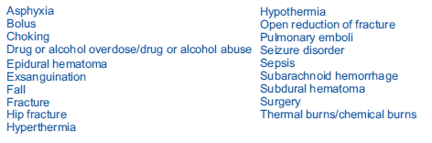
Such cases should be reported to the medical examiner/coroner.

Coroners must complete the Coroner Review to complete certification.

In some cases, coroners may be able to complete certification without completing the coroner review. However, when this happens the status bar at the top of the page will read Coroner Review Required:

In this case the Local Health Department (LHD) will not be able to print the certificates.

In most cases the coroner will be able to access the case but will be unable to complete the cause of death.

In the blue menu at left, under the Other Links heading will be the active link: Coroner Review Case

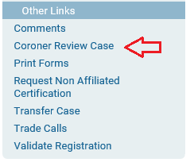

When Coroner Review Case is accessed a window with three fields will appear. The first will be a drop menu asking to Accept or Decline the case or note that it is Pending.

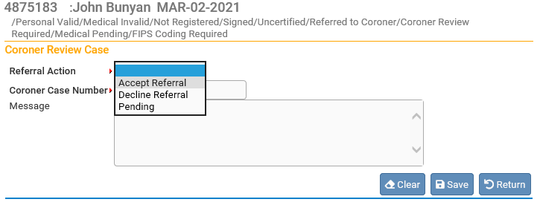

Once accepted the Coroner Case Number can be entered. Also, an auto-populated message will appear with case information. This message can be overwritten, or simply added onto.

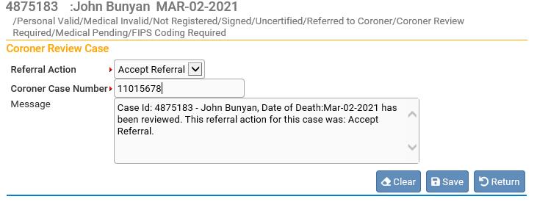

Once the Save button is clicked the status bar will change to indicate that the case is Under Coroner Review.

The Cause of Death can now be completed so that the case can be certified.

